BRACKET 1 – APPLICATION: TO HOLD UP TO 1 AWG SPEAKER WIRE, USES STANDARD NAIL SIZE

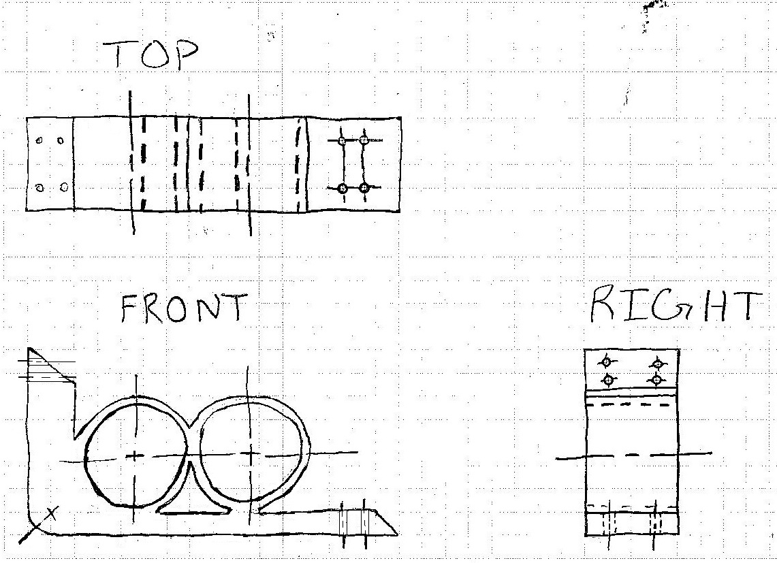

BRACKET 2 – APPLICATION: TO HOLD WALLPAPER BETWEEN WALL EDGES

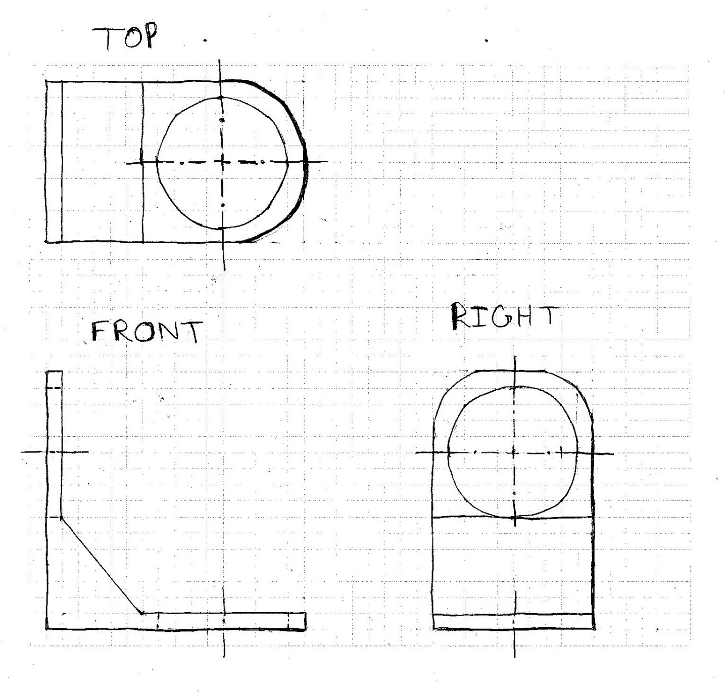

BRACKET 3 – APPLICATION: A FREE APPROACH TO HOLD UP TO 2X 1 AWG WIRE

